

**Assignment No: 01**

Submitted by:

Name : Haseeb Ullah

ID: F20232661009

Section: V21

Submitted to:

Name: Sir M Owais Khan

Assignment No: 04

**Address:** C-II Block C 2 Phase 1 Johar Town, Lahore, Punjab 54770.

University of Management & Technology.

* 1. Write a C++ program to update every array element by multiplication of next and previous values of a given array of integers.

|  |
| --- |
| #include <iostream>  using namespace std;  int main()  {  long long a[11]={4,2,2,1,5,2,3,4,6,2,2},  b[10];  int next = 0,previous = 0;  for (int i = 0; i < 10 ; i++)  {  b[i]=a[previous] * a[++next];  next = ++i;  previous = --i;    }  cout << endl;  for (int i = 0; i < 10; i++)  {  cout << b[i] << " ";  }        return 0;  } |

Output

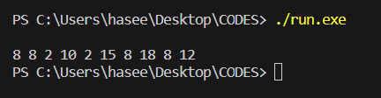

* 1. Find a pair with the given sum in an array.

|  |
| --- |
| #include <iostream>  using namespace std;  int main()  {  int arr[6]={5,3,8,2,3,7};  int somethingforexample = 10;  for (int i = 0; i < 6; i++)  {  for (int j = i; j < 6; j++)  {    if (arr[i] + arr[j] == somethingforexample)  {  cout << "Index: " << i << " and "<< j << " = " << arr[i] + arr[j]<<endl;  }  }  }    return 0;  } |

Output

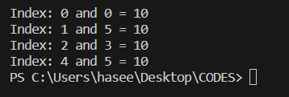

* 1. Find the maximum product of two integers in an array

|  |
| --- |
| // 1.3. Find the maximum product of two integers in an array  #include <iostream>  using namespace std;  int main()  {  int arr[10]={4,56,0,34,55,23,1,0,32,0};  int firstMaxNum = arr[0],  secMaxNum = arr[0],  index;  for (int i = 0; i < 10; i++)  {  if (arr[i] > firstMaxNum)  {  firstMaxNum = arr[i];  index = i;  }else if (index == i)  {  continue;  }  else if (arr[i] > secMaxNum)  {  secMaxNum = arr[i];  }  }    cout << "max: " << firstMaxNum<<endl;  cout << "Secon max: " << secMaxNum << endl;  cout << "the maximum product of two integers in an array is: " << secMaxNum * firstMaxNum << endl;    return 0;  } |

Output

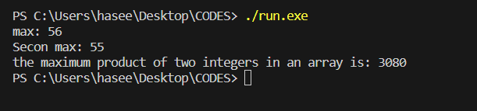

* 1. Move all zeros present in an array to the end

|  |
| --- |
| // 1.4. Move all zeros present in an array to the end  #include <iostream>  using namespace std;  int main()  {  int arr[10]= {0,65,0,34,0,34,23,0,2,9};    for (int i = 0; i < 10 -1; i++)  {  for (int j = 0; j < 10 - 1; j++)  {  if (arr[j] == 0 && arr[j + 1] != 0)  {  int temp = arr[j];  arr[j] = arr[j + 1];  arr[j + 1] = temp;  }    }    }    for (int i = 0; i < 10; i++)  {  cout << arr[i] << " ";  }      return 0;  } |

Output

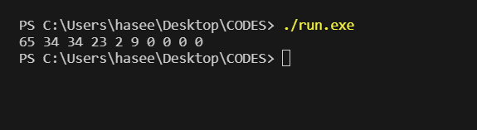

* 1. Write a C++ program to search for any element in an array.

|  |
| --- |
| #include <iostream>  using namespace std;  int main()  {  int arr[10] = {23,45,12,67,34,67,3,67,32,67};  int search;  bool found = false;  cout << "Enter the numbrer for search : ";  cin >> search;  for (int i = 0; i < 10; i++)  {  if (arr[i] == search)  {  cout << "the num is found: " << arr[i]<<endl;  found = true;  break;  }    }    if (!found)  {  cout << "number is not found.";  }    return 0;  } |

Output

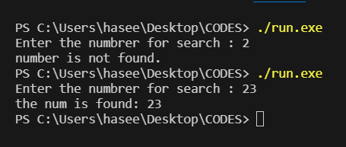

* 1. Write a C++ program to reverse an array.

|  |
| --- |
| #include <iostream>  using namespace std;  int main()  {  int arr[10] = {1,2,3,4,5,6,7,8,9,99};  cout << "reverse array: ";  for (int i = 10 - 1; i >=0; i--)  {  cout << arr[i] << " ";  }    return 0;  } |

Output

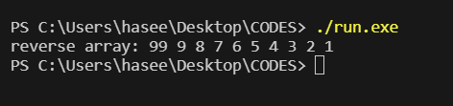

* 1. Write a C++ program to print the multiplication of two matrices.

|  |
| --- |
| #include <iostream>  using namespace std;  int main()  {  int mat1[2][2]={  {1,1},  {3,-2}  };  int mat2[2][2]={  {1,1},  {3,-2}  };  int mat3[2][2];  for (int i = 0; i < 2; i++)  {  for (int j = 0; j < 2; j++)  {  mat3[i][j] = 0;  mat3[i][j]=mat1[i][j]*mat2[i][j];  for (int k = 1; k < 2; k++)  {  mat3[i][j] += mat1[i][k]*mat2[k][j];  }  }    }    for (int i = 0; i < 2; i++)  {  for (int j = 0; j < 2; j++)  {  cout << mat3[i][j]<< " ";  }  cout<<endl;  }  return 0;  } |

Ouput

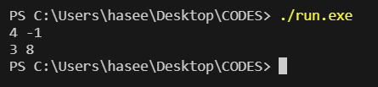

* 1. Write a C++ program to print the addition of two matrices

|  |
| --- |
| #include <iostream>  using namespace std;  int main() {  int mat1[3][3] = {{1, 2, 3},  {4, 5, 6},  {7, 8, 9}};  int mat2[3][3] = {{1, 2, 3},  {4, 5, 6},  {7, 8, 9}};  int result[3][3];  for (int i = 0; i < 3; i++)  {  for (int j = 0; j < 3; j++)  {  result[i][j] = mat1[i][j] + mat2[i][j];  }  }  cout << "addition of two matices:" <<endl;  for (int i = 0; i < 3; i++)  {  for (int j = 0; j < 3; j++)  {  cout << result[i][j] << " ";  }  cout << endl;  }  return 0;  } |

Output

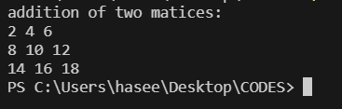

* 1. Write a C++ program to calculate area and circumference of a circle using function.

|  |
| --- |
| #include <iostream>  #include <cmath>  using namespace std;  // 2.1. Write a C++ program to calculate area and circumference of a circle using function.  double aa(double r, double pi)  {  return pi * pow(r,2);  }  double circumf(double r, double pi)  {  return 2* pi * r;  }  int main()  {  double r, pi = 3.14;  cout << "Enter radius: ";  cin >> r;  double area = aa(r, pi);  double circumference = circumf(r, pi);  cout << "Area of the circle is: " << area << "\n";  cout << "circumference of the circle is: " << circumference << "\n";      return 0;  } |

Output

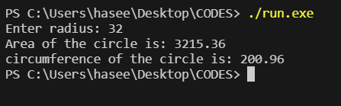

* 1. Write a C++ program to calculate area and perimeter of square and rectangle using function.

|  |
| --- |
| #include <iostream>  #include <cmath>  using namespace std;  // 2.2. Write a C++ program to calculate area and perimeter of square and rectangle using function  double aside(double side)  {  return side * side;  }  double perside(double side)  {  return 4 * side;  }  double rectA(double length, double width)  {  return length * width;  }  double per_rect_A(double length, double width)  {  return 4 * (length + width);  }  int main()  {    double side,length,width;  cout << "Enter the side: ";  cin >> side;  cout << "Enter the length: ";  cin >> length;  cout << "Enter the width: ";  cin >> width;  double side_area = aside(side);  double side_perimetter = perside(side);  double rectangle_area = rectA(length, width);  double rectangle_perimetter = per_rect_A(length, width);  cout << "The side area is: " << side_area <<endl;  cout << "The Perimetter side area is: " << side_perimetter <<endl;  cout << "The rectangle area is: " << rectangle_area <<endl;  cout << "The Perimetter rectangle area is: " << rectangle_perimetter <<endl;      return 0;  } |

Output

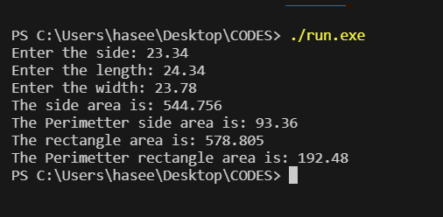

* 1. Write a C++ program to convert temperature from Fahrenheit to Centigrade using function.

|  |
| --- |
| #include <iostream>  using namespace std;  float fahrenheitto(float fahrenheit) {  return (fahrenheit - 32) * 5 / 9;  }  int main() {  float fahrenheit, celsius;  cout << "tnter temperature in fahrenheit: ";  cin >> fahrenheit;  celsius = fahrenheitto(fahrenheit);  cout << "temperature in celsius: " << celsius << endl;  return 0;  } |

Output

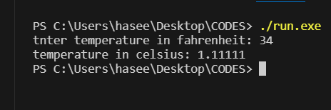

* 1. Write a C++ program to print the Factorial of a number using the recursion function.

|  |
| --- |
| #include <iostream>  using namespace std;  long double fac(double n){  if (n < 1)  {  return 1;  }else  {  return n * fac(n - 1);;  }    }  int main() {    double n;  cout << "Enter the number you want factorial: ";  cin>>n;  double factorial = fac(n);  cout << "Factorial is: "<< factorial;  return 0;  } |

Output:

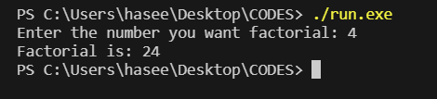

* 1. Write a C++ program to read 'n' numbers and print the number with the maximum sum of digits.

|  |
| --- |
| #include <iostream>  using namespace std;  int main() {  int num, sum = 0, max=0, n = 5;    for (int i = 0; i < n; i++)  {  cout << "Enter the number: ";  cin>>num;  sum += num;  if (num > max)  {  max = num;  }    }  cout << "the total sum is: " <<sum<<endl;  cout << "the max sum is: " <<max<<endl;  return 0;  } |

Output

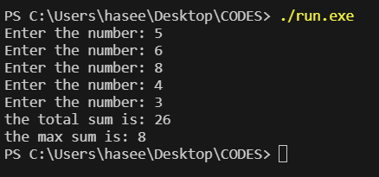

* 1. Write a C++ program to calculate the grade of a student on the basis of his/her total marks using functions.

|  |
| --- |
| // 2.6. Write a C++ program to find the sum of digits of a number using a recursive function.  #include <iostream>  using namespace std;  char calculate_grade(float percentage) {  if (percentage >= 90)  return 'A';  else if (percentage >= 80)  return 'B';  else if (percentage >= 70)  return 'C';  else if (percentage >= 60)  return 'D';  else if (percentage >= 50)  return 'E';  else  return 'F';  }  int main() {  float marks,percentage,totalmarks;    cout << "Enter total marks: ";  cin >> totalmarks;  cout << "Enter obtained marks: ";  cin >>marks;  percentage = (marks/totalmarks) * 100;  char grade = calculate_grade(percentage);  cout << "your grade is: " << grade << endl;  return 0;  } |

Output

